Larry Baucum

CTEC 393

5/17/2024

<http://www.ctec293baucum.x10.mx/>

**Database Update Snapshot Before**

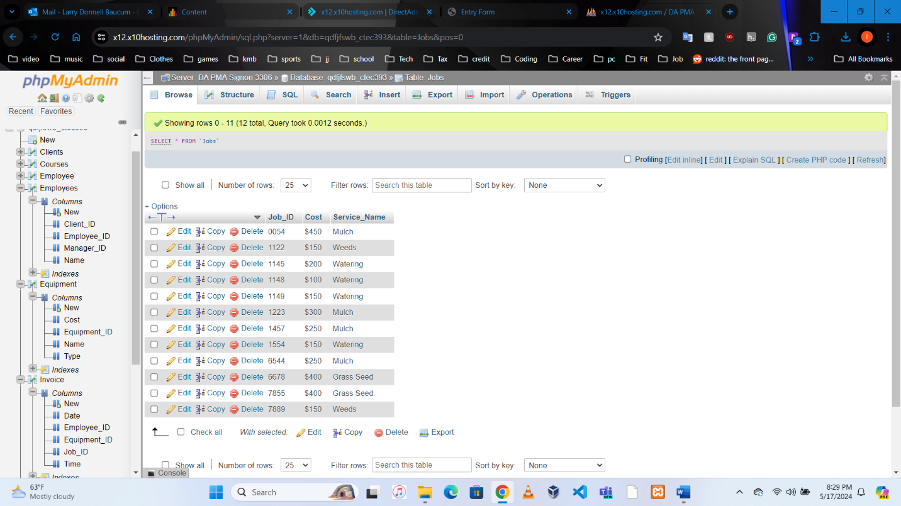

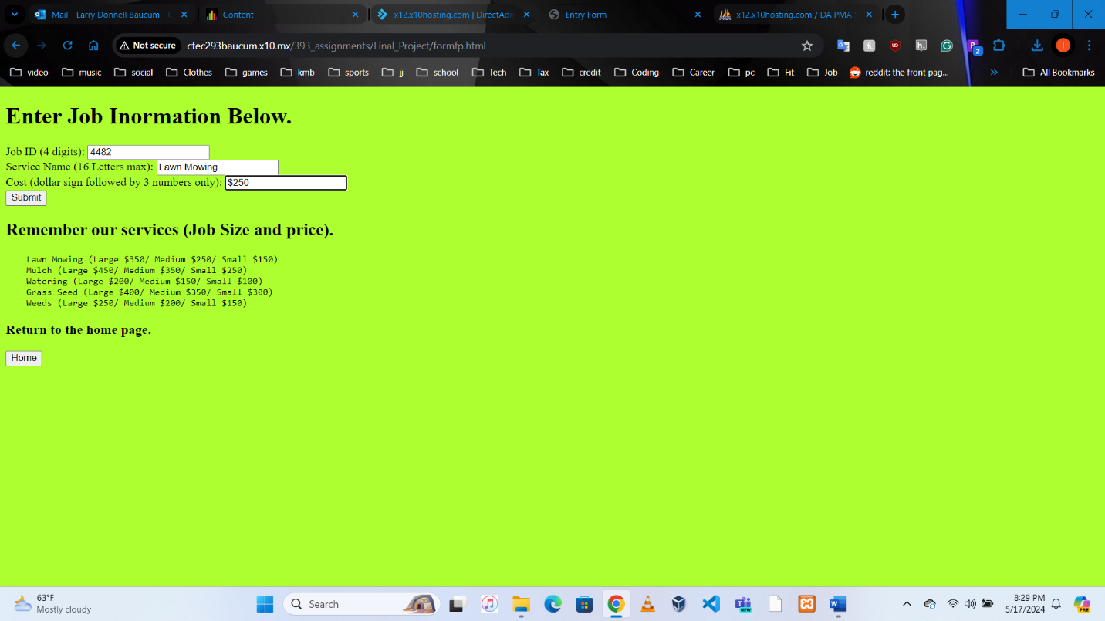

**Database Update Snapshot After**

